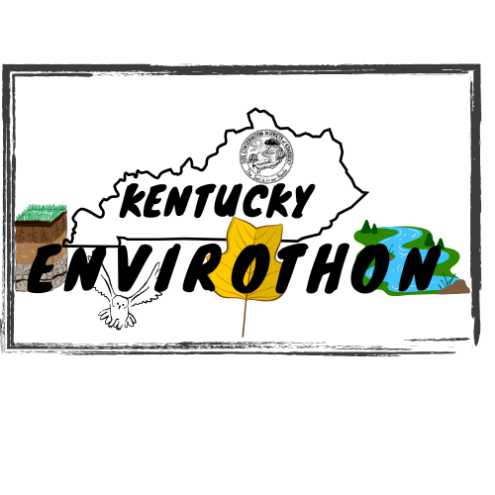
.

Participant’s Name (please print): ______________________________________
Parent’s Name (please print): __________________________________________

I hereby grant permission for my child to participate in the 2026 Envirothon Competition. I realize that this event may be strenuous, and that adverse weather conditions may occur. Nevertheless, I wish for my child to participate and hereby assume the risk involved.
I certify that my son/daughter is in good health and he/she is able to participate in this event. I authorize the Kentucky Envirothon program to provide emergency medical attention for my child during this event. I have been assured that all reasonable care will be taken to prevent incident, therefore I will not hold Kentucky Envirothon liable should an accident occur.
I fully understand the scope of this activity and voluntarily sign this form.

__________________________________________ ________________________
Participant’s Signature Date

__________________________________________ ________________________
Parent/Guardian’s Signature Date
(if Participant is Under 18)

MEDICAL
INFORMATION

Please Print
Participant’s Full Name: ____________________________________________________

Parent/Guardian’s Name: ___________________________________________________

Address: __________________________________________________________________
(street & apartment) (City, State Zip)

Telephone: _____________________________________

Person to contact in case of emergency: _____________________________________

Contact Person’s Phone Number: _____________________________________

Insurance Carrier: ______________________ Policy #: _________________________

Allergies (medication, food, etc.) ___________________________________________

_____________________________________________________________________

Medications currently being taken: __________________________________________

Person completing form: ___________________________________________________ ______

Parent/Guardian’s Signature: _________________________________________

Date: ___________________________________

PHOTO RELEASE

Please Print
Participant’s Full Name: _________________________________________________

Parent/Guardian’s Name: _________________________________________________

Telephone: ______________________________________

I hereby consent to the use of this photograph of my child/dependent/self, and/or any copies of this photograph in any editorial and/or promotional material produced and/or published by the Kentucky Envirothon.

Participant’s Signature: ________________________________________________

Parent/Guardian’s Signature: ___________________________________________

Date: __________________________

